**Experiment No. 3**

|  |
| --- |
| Student Name: SANSKAR AGRAWAL UID: 20BCS5914 |
| Branch: BE-CSE Section/Group: 806-B |
| Semester: 5th Subject: Machine Learning Lab |

**Aim:** In this experiment we are doing Linear Regression Implementation on Diabetes Dataset

**Software/Hardware Requirements:** Windows 7 & above version

**Tools to be used:**

* + Anaconda Navigator

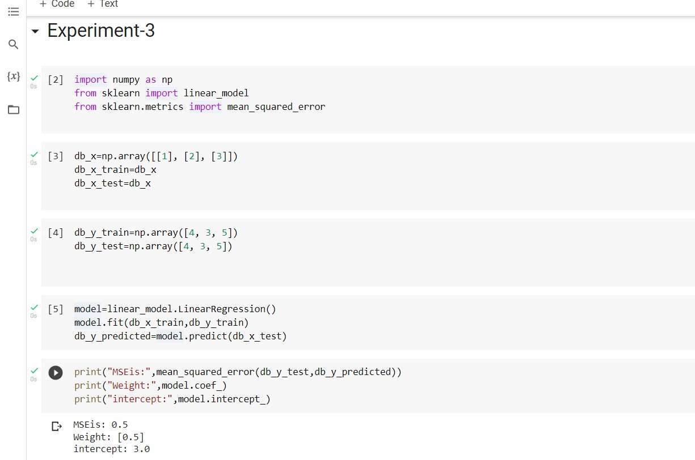 **Implementation:**

